Career Day Vision Board Lesson Plans

Learning Intention:
- To create a vision board, linked to SMART goals (Specific, Measurable, Attainable, Relevant, Time-bound)

Success Criteria:
- Students will identify skills required to do some jobs
- Students will make links between school subjects and skills required for jobs
- Students will identify 3 things they would like to achieve when they get older
- Students will identify 3 current goals that they can work on now, to assist them in reaching their future goals

Lesson 1
Think/Pair/Share

Whole class: Ask students to discuss the different professions they saw at careers day. Use images or show a video to remind students about the day.

Teacher records professions on board

Teacher focus on one job e.g. chef, discuss as class, what things the person would need to be good at in order to do that job

Students continue with partner recording skills person would need to do another job on the list

Whole Class: report back and record findings, link what subjects at school would assist with the skills needed

Students- complete ‘Links Worksheet’

Lesson 2
Whole Class: Discuss the life and work of a famous musician/artist/movie star/famous chef

Students: Carousel listing what things each profession would need to love, in order to be successful in their career for example, a musician loves music/words/performing etc

Students: reflect on what they love in their life, complete worksheet

Whole Class: show example of a vision board, ask students to gather photographs/magazine cuttings of things that they love/inspire them

Students: Create vision board

Whole Class: discuss and share with peers

Lesson 3
Whole Class: Discuss the acronym SMART in relation to goals, why each assist in the success of attaining goal

Paired work: practice memorising the acronym SMART

Whole Class: highlight different SMART aspects of a chosen goal

Paired work: students highlight the different aspects of SMART in a prepared goal

Whole Class: students self-assess their work with the teacher

Lesson 4
Whole Class: Look at a teacher’s vision board, discuss the goals that need to be identified and achieved in order to achieve the dream. For example, to be a vet, good at science, set SMART goal in relation to where they are at in science just now

Partners: work together to identify steps needed to be taken now to work towards vision, complete goal sheet

Whole class: discuss student's goals and check using first to five if they are SMART goals

Students have goals in a place visible to them, as a reminder and motivator

Lesson 5

Ongoing Check In
Whole Class: discussion about the importance of reflection/evaluation/adjustment of goals
Partner Share: success achieved/ readjustments made
Individual: update goals accordingly

Career Links

Name: Date:
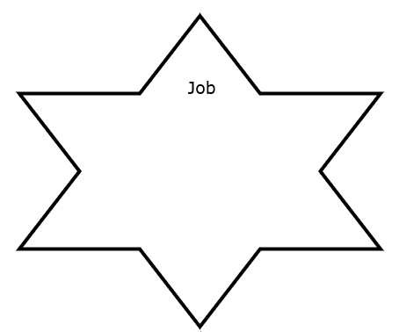
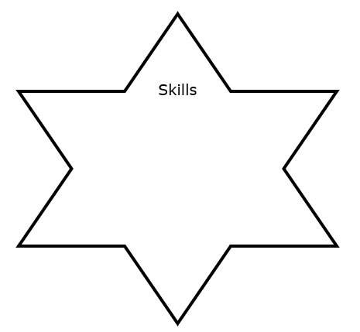
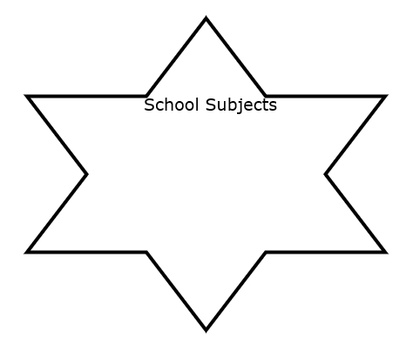

My inspirations

Name: Date:

My goals

Name: Date:

GOAL






